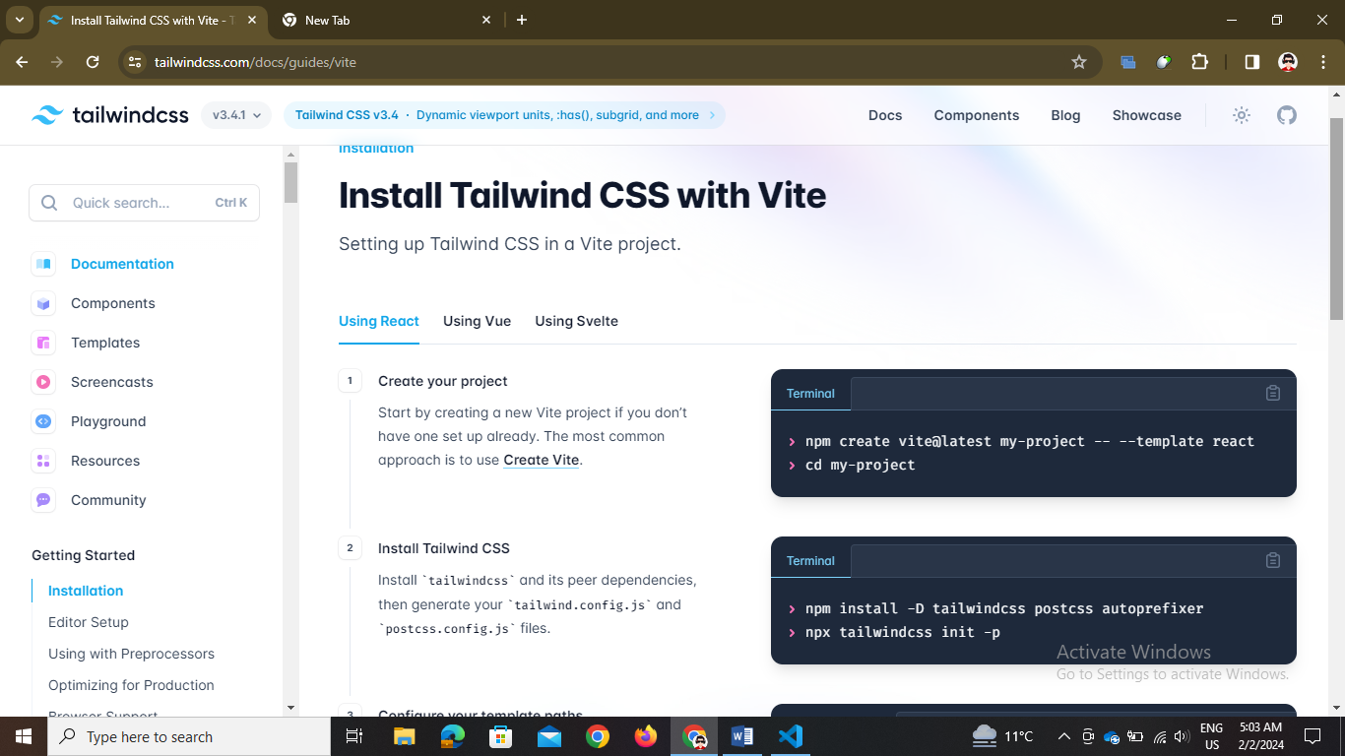

// make tailwind available in the vite by going to frameworks and then follow the instructions

 return (

    <>

      <h1 className="bg-green-400 text-black rounded-2xl p-4">Tailwind Test</h1>

    </>

  );

}

// use this type of classes like bg-green and others to give styling

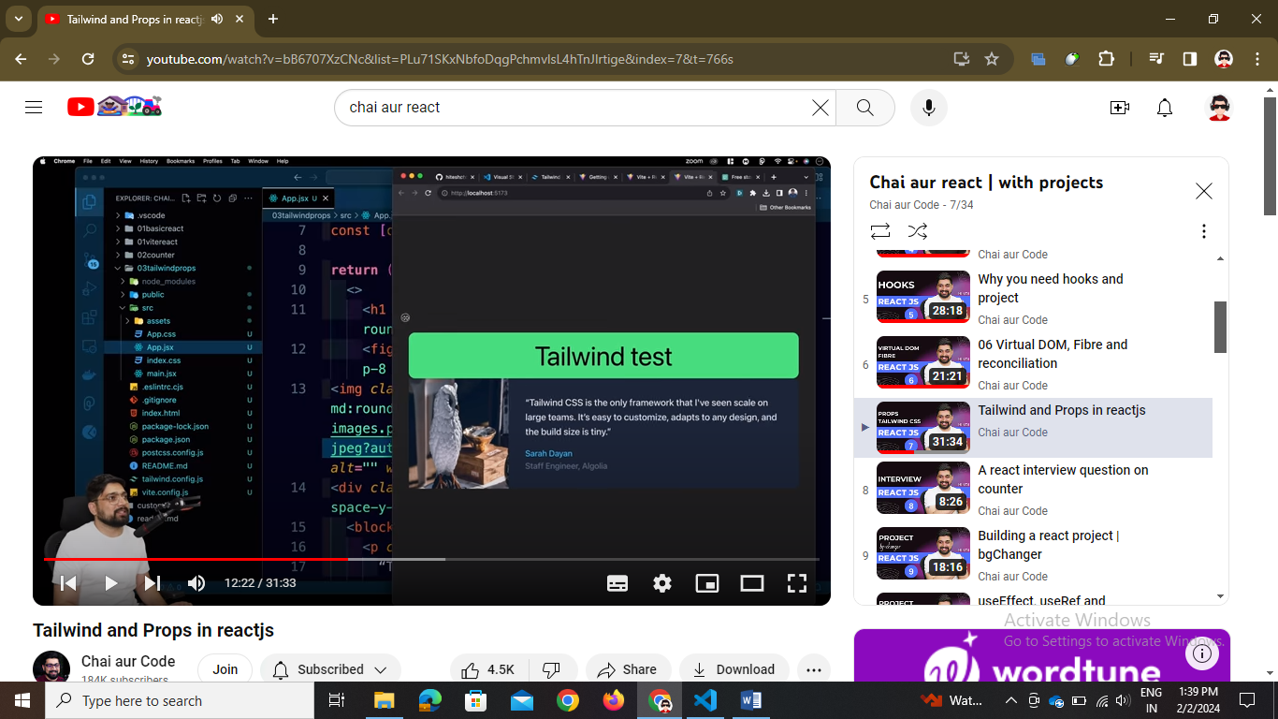

// we can use card as it is in the tailwind copy that and use it

// also it is tailwind so it is responsive -🡪 tailwind is always responsive

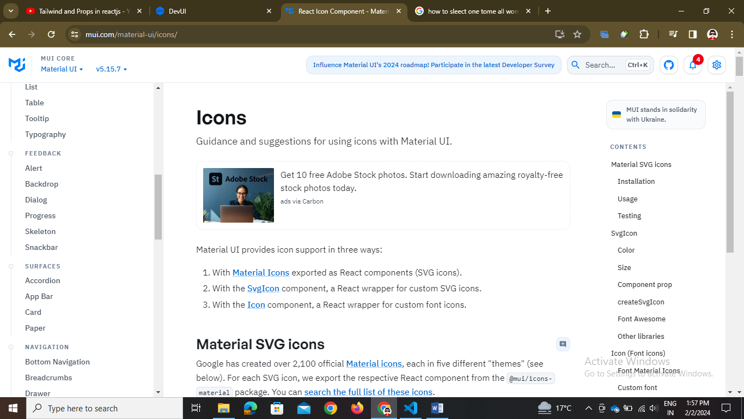

// in this we can install it in react and use the components

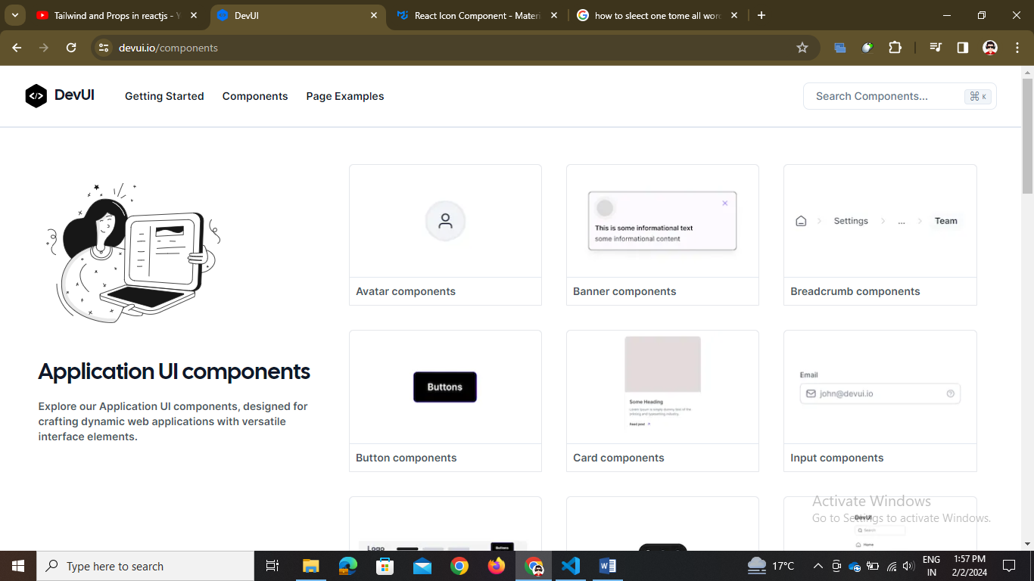

// both are use to give react components …

Note 🡪 Ctrl + Shift + L is use to select all the same words at same time and change at one time

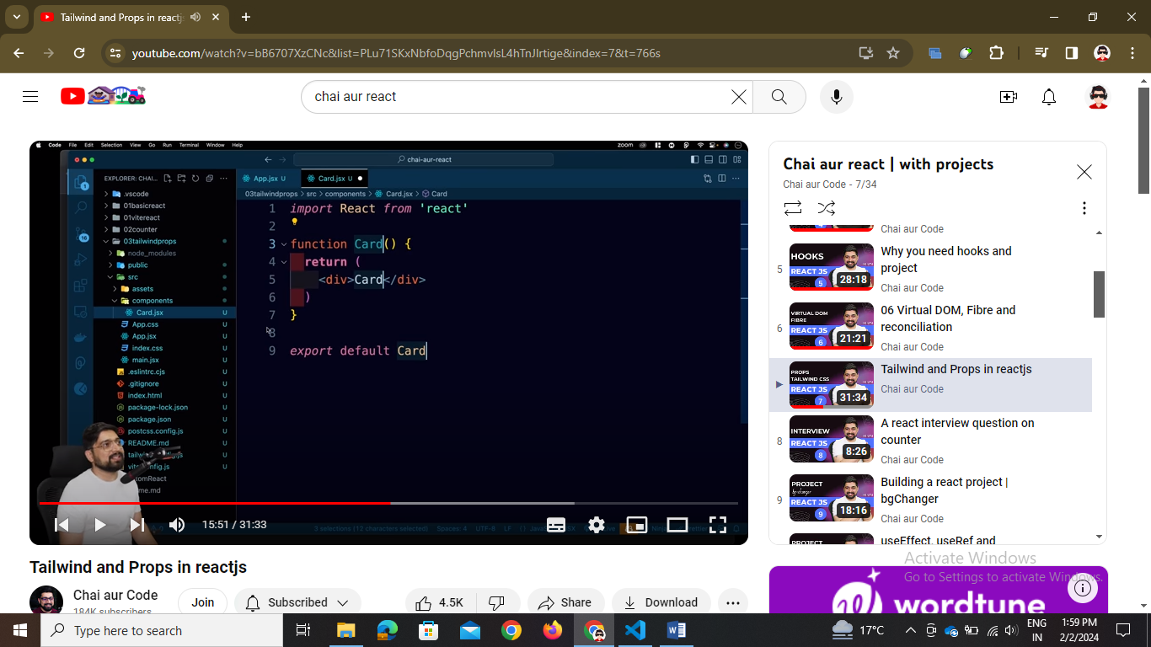

Note 🡪 // rfce is use to write the component immediately -🡪 write the card.jsx in the component folder

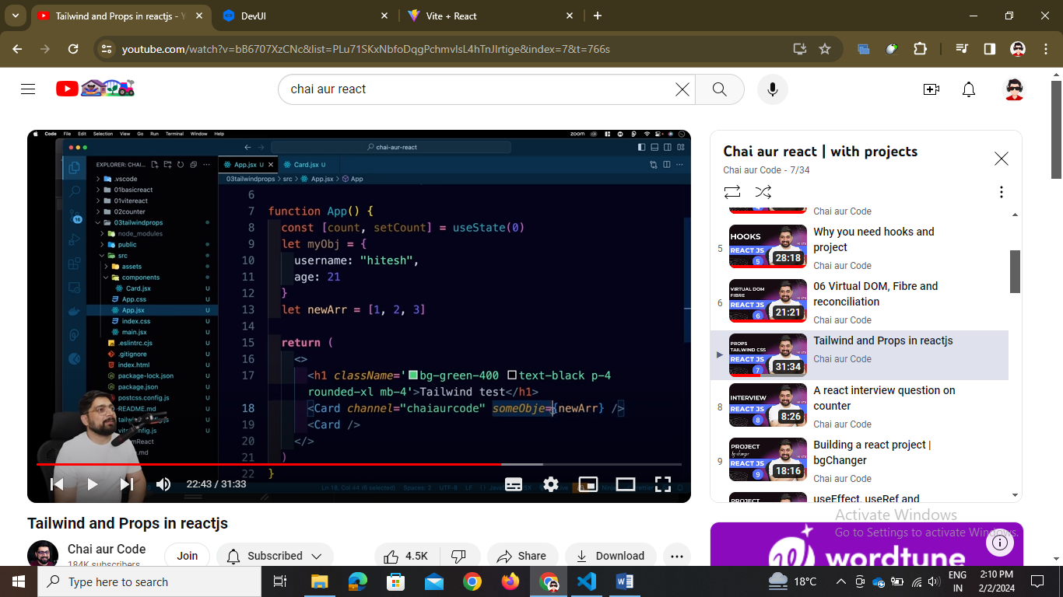

So we have props in the child component as a argument to pass function Card(props){}

Or we can pass directly the js form Card({username, text}) and pass these values from the app.jsx where the card component is used

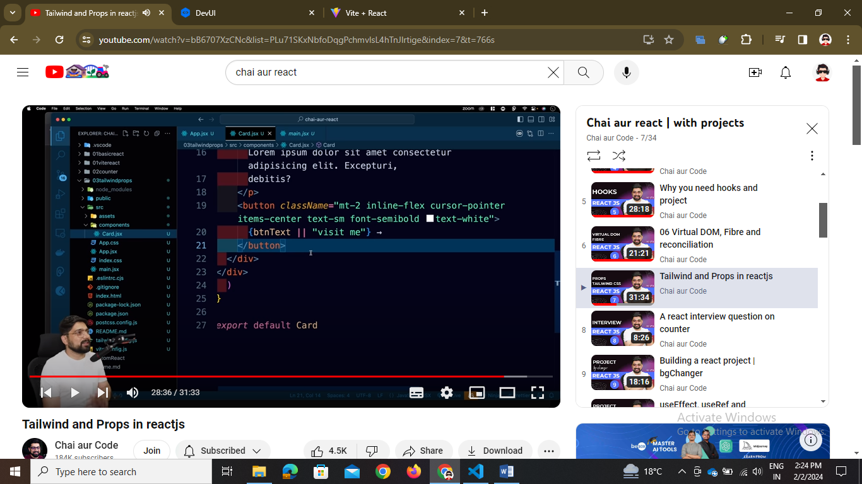

Default statement

          <h1 class="text-lg font-semibold text-white">{username}</h1>

// we can use that prop in card as { } in this

Note 🡪 arrow function named expression

// () => { } callback function or arrow function

*// Example 3: Arrow function with no parameters*  
const sayHello = () => console.log("Hello, world!");